Problem Statement : Detect Anomaly in a cloud infrastructure(system metrics) in order to avoid a certain type of crash.

Specifically : Univariate AD

Common Challenges :
1. Time Series is often non-stationary. means with time it's statistics changes.
2. supervised approaches insufficient in online applications and not feasible in terms of creating labeld dataset. So , only Unsupervised approaches needs to be looked.

Goal :
1. A Model should be tolerant to noisy data, conti-nously adapts to changes in the statistics of the data, and detects very subtle anomalies while minimizing false positives.
2. Most common & imporatant Anomaly types which a model needs to handle at least. Those are
a. Spatial
b. Temporal
3. Early Detection of Anomaly

Evaluation Metrics :
using Plot-diagram --> used for test.
Ofcourse there are other metrics like Precision,Recall,F1-score can be used for evaluation.

Solutions that are reasonable for trying out with any model :
1. Decomposition models(classical decomposition, STL) perform well at TS task by explicitly removing correlated components (seasonality, trend) from the timeseries — giving opportunity to apply statistical tests with gaussian assumptions on the residuals whilst preserving the anomalies’ original attributes.
2. Contineous update of model required to adapt to change of statistics in TS with time.
3. Model has to also learn the variability of period like hourly, daily, weekly and monthly basis.
4. do not forget to scale input features.

* After having understanding and trial of different approach on Anomaly detection , below are my observations. Specifically what are different approaches availabel and their pros & cons. Of course i have not outlined detailed information. For basic & more detail understanding please follow references.

1. statistical approach
pros : computationaly fast(online learning can be done easily)
cons : feature-engineering required, more False Positive Rates if threshold not selected properly

To handle Non-stationarity : (rule-based multiple-models method)
1. create stationary representation of data using seasonal_decompose algo.
2. create Exponential Moving/Weighted Average model for each decomposed data(trend,sessional,noise).
3. use handcrafted rule(having domain understanding) on above models to get anomaly.

2. Machine Learning approach
pros : data needs to be stationary except Neural Network(which can handle non-stationary), better performance compare to statistical model considering all time series properties.
cons : computationaly slow(online learning can be difficult if requirement of inference is in milliseconds),
feature-engineering required except Neural Network,
less False Positive Rates,
supervised data required for supervised model,
unsupervised model as distance based model : not good at handling context aware anomaly unless projected with context aware

To handle Non-stationary : (rule-based multiple-models method)
one can follow rule-based multiple-models method like statistical approach.
Neural-Network model :
1. forecast future, then get residual between predicted and expected and finally use distance-based or distribution based model to get anomaly.
2. feature compression method : using Autoencoders get residual between predicted & expected and finally use distance-based or distribution based model to get anomaly.

3. Hybrid approach
combine statistical model with machine learning model.
Or Ensemble of algorithms can be used to get better performance as they as errors from one algorithm doesn’t necesserily co-rrelate with each others.

Best Algorithms in terms of good performance till now ?
There is no single model which can work on all type(domain) of data. all these models have shown good performance w.r.t single domain. so user needs to tweak parameters of any model to get best result for it's domain.

Best Algorithms in terms of inference latency till now ?
Fast inference in terms of milliseconds :
1. Numenta(HTM)(focus on spatial & temporal.)
2. PBAD(pattern based anomaly detection)(focus on spatial & temporal.)
3. Twitter(S-H-ESD)(focus on spatial & temporal.)
4. EGADS(from Yahoo)(good for batch processing. Not useful for online streaming data.)
5. ARIMA(focus on spatial & temporal. But parameter deciding is difficult.)
6. Holt-Winters (focus on spatial anomalies, limiting their usefulness in applications with temporal dependencies.)

Slow Inference in terms of milliseconds : usually this happens because of iterative process of finding anomaly and updating sequence.
1. LSTM
2. LSTM-based Autoencoders
3. Variational Auto-Encoder(VAE) : it can be leveraged to model the reconstruction probabilities of normal time-series,while the abnormal points were reported if the reconstruction error was larger than a threshold.
4. GRU-AE using Mahalanobis distance for scoring anomaly.

Alternatives of Neural Network model for fast inference :
1. get forecast of value n-time step ahead. and then at given or current time step, calculate anomaly score.
Exceptional(can be best model over above all) : inference is faster compare to lstm
1. CNN
2. SR-CNN : Spectral Residual & Convolutional Neural Network

More Details on each Algorithms :

Luminol EMA algo :
1. To find Anomaly Scores for each data point, below is the formula.
Anomaly score for a single data point(t,v) equals: abs(v - ema(lagging window)) / stdev
where t -> each time instance OR data point at that time instance
v -> actual value of single data point
ema -> exponential moving average of that data point
lagging window -> 0.2(Default) * (total number of data point OR size of input time series)
stdev -> standard deviation considering total number of data points
2. for finding threshold, below is the formula.
threshold = threshold or max_anom_score * score_percent_threshold
where max_anom_score -> get max anomaly score from all data points anomaly score.
threshold -> 3(Default)
score_percent_threshold -> 0.2(Default)
3. check for Anomaly :
if value > threshold:
Pros: good for stable & unstable data.
Cons: parameter-sensitive

Luminol bitmap algo :
Luminol uses a bitmap representation of a univariate time series, calculated using symbolic aggregate approximation (SAX)—a method for the discretisation of time-series data to detect anomalies. This is implemented using two concatenated windows, a lagged window and a leading window, which slide across the time series. Each window is then converted into a SAX representation and subsequently into bitmaps based on the frequency of each SAX subword. The distance between the two bitmaps is calculated and represents the anomaly score for the leading window. The calculated anomaly scores are then tested using a grid search-optimised threshold-based anomaly detector. In order to transform the three environmental variables into a univariate time series, the first principal component was taken.
Pros : good for stable & unstable data.
Cons : parameter-sensitive

Twitters AnomalyDetection Algo :
- it uses S-H-ESD algorithm for anomaly detection. it's a wrapper over ESD algorithm. S -> stands for session-al and H -> stands for Hybrid and ESD -> stands for the generalized (extreme Studentized deviate) ESD test. which is used to detect one or more outliers in a univariate data set that follows an approximately normal distribution.
- The generalized ESD test is defined for the hypothesis:
H0: There are no outliers in the data set
Ha: There are up to r outliers in the data set
Test Statistic: Compute
Ri = (maxi|xi−x¯|) / s
with x¯ and s denoting the sample mean and sample standard deviation, respectively.

Remove the observation that maximizes |xi−x¯| and then recompute the above statistic with n - 1 observations. Repeat this process until r observations have been removed. This results in the r test statistics R1, R2, ..., Rr.
- then it does one more test by checking r critical values Corresponding to the r test statistics.
λi = ((n−i)tp,n−i−1) / square root of ((n−i−1+t2p,n−i−1)(n−i+1)) where i=1,2,…,r
where tp,ν is the 100p percentage point from the t distribution with ν degrees of freedom and
p=1−α2(n−i+1)
The number of outliers is determined by finding the largest i such that Ri > λi.
Pros : good for stable & unstable data. Not much good for sessional data.
Cons : fails to detect the changepoint, Limitation of ESD method is finding number of k-anomalies. but this can be set, by finding number of average anomalies in different periods like hour, day, week, month..etc.

Numenta AnomalyDetection Algo : Numenta(Nupic) (https://github.com/numenta/nupic)(http://nupic.docs.numenta.org/stable/guides/opf.html)
1. HTM is a machinelearning algorithm derived from neuroscience that modelsspatial and temporal patterns in streaming data.
2. HTMs have been shown to work well for prediction tasks but HTM net-works do not directly output an anomaly score.
3. In order to perform anomaly detection, Numenta(Nupic) utilize two different internal representations available in the HTM.
a. Given an input Xt, the vector a(Xt) is a sparse binary code representing the current input.
b. another is internal state vector π(Xt) which represents a prediction for a (Xt+1), i.e. a prediction of the next input Xt+1.
4. once these two vectors got computed, then first compute a raw anomaly score from the two sparse vectors.
5. then compute ananomaly likelihood value which is thresholded to determine whether the system is anomolous. Below is the block-diagram. Screen-shot from https://arxiv.org/pdf/1607.02480.pdf.

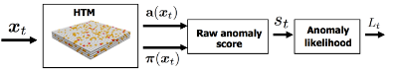

6. raw anomaly score that measures the deviation between the model’s predicted input and the actual input. below is the formula.
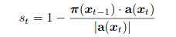

7. then model the distribution of anomaly scores and use this distribution to check for the likelihood that the current state is anomalous. below are the formulas used to compute likelihood.
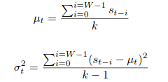

8. then compute a recent short term average of anomaly scores, and apply a threshold to the Gaussian tail probability to decide whether or not to declare an anomaly. This is to define the anomaly likelihood as the complement of the tail probability:

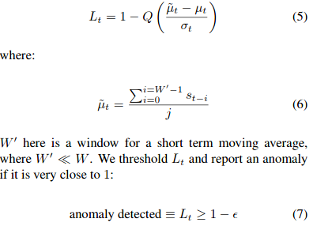

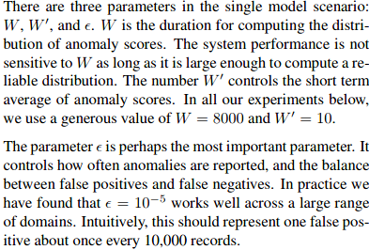

Engineering side of Numenta Nupic : please refere to this doc(http://nupic.docs.numenta.org/stable/guides/opf.html). This doc has every details of building application.
Pros : good for stable, unstable & sessional data . Also detects the changepoint in TS.
As this algorithm uses online learning algorithm. So user doesn’t have to use more data for getting initial model parameter. Just with ~50k samples user can swarm(select model parameters.)
Cons : user has to select right anomaly_likelihood value in order to reduce FP.
While testing for ~4 months data , after 1 days of online learning, then process gets slow(Not Sure exact Reason)

How to select right model for your problem ?
using iterative approach : take a basic model, observe Anomalies, analyse it and based on analysis choose next best model.

NOTE:
Above observation is subjected to my exposure of contents available in Internet. I may have missed some latest work or some other good information. if so, any user can change above observations.

Work:
All works are i have done using notebooks.

References:
http://courses.cs.vt.edu/cs5824/Fall15/project_reports/nayyar_vishwasrao_chakravarty_dabiri.pdf
https://ecmlpkdd2019.org/downloads/paper/681.pdf
https://arxiv.org/pdf/1607.02480.pdf
https://www.hindawi.com/journals/complexity/2019/2686378/
https://pdfs.semanticscholar.org/a0ea/7933ef45fcc9b8d628dc41b0a4afa376fc67.pdf
https://arxiv.org/pdf/1906.03821.pdf
https://papers.nips.cc/paper/7462-precision-and-recall-for-time-series.pdf
https://www.mdpi.com/1424-8220/18/8/2521/htm
https://pdfs.semanticscholar.org/909b/8226968d41f76cc14d0eef2d365572e7a37b.pdf?_ga=2.167377982.1813224798.1577087411-1002764475.1534934788
https://docs.waylay.io/features/tsanalytics/tsanalytics_models/
https://www.ncbi.nlm.nih.gov/pmc/articles/PMC4367333/
https://arxiv.org/pdf/1708.08053v1.pdf
https://www.mdpi.com/1424-8220/18/8/2491/htm
https://arxiv.org/pdf/1901.03407v2.pdf
https://arxiv.org/pdf/1811.12119.pdf
https://ieeexplore.ieee.org/stamp/stamp.jsp?arnumber=8364549
https://github.com/numenta/htmpapers/tree/master/neurocomputing/unsupervised_real_time_anomaly_detection_for_streaming_data

Sample Plots : using RAW data.
Original Data : two types of data representation.

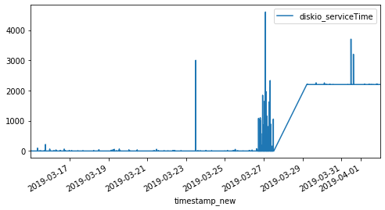

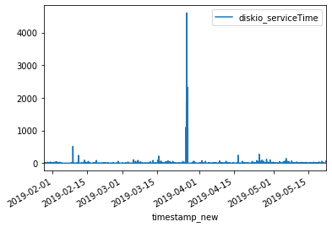

Twitter Output :
`outliers_indices = sesd.seasonal_esd(df,seasonality = 24*60*80, hybrid=True, max_anomalies=10, alpha = 0.05)`

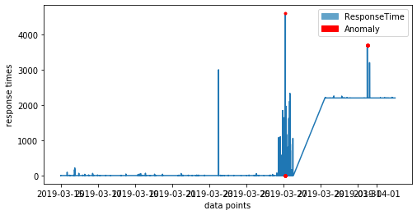

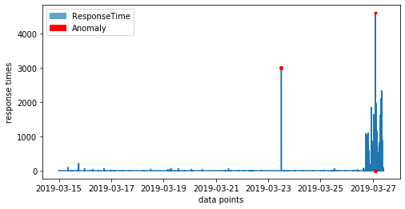

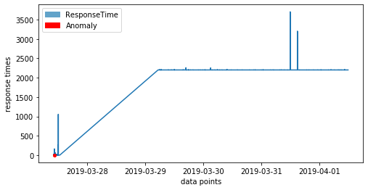

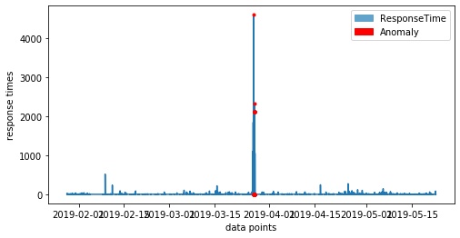

Luminol Output :
`algorithm_name = 'bitmap_detector'
algorithm_params = {
'precision': 4,# how many sections to categorize values,
'lag_window_size': 24*60*80,#80000,# lagging window size,
'future_window_size': 60*80,#80000,# future window size,
'chunk_size': 2# chunk size.
}
detector = anomaly_detector.AnomalyDetector(ts_dict,score_percent_threshold=0.2,algorithm_name=algorithm_name,
algorithm_params=algorithm_params)#,score_percentile_threshold=0.1
#detector = anomaly_detector.AnomalyDetector(ts_dict,algorithm_name=algorithm_name)#,score_percentile_threshold=0.1`

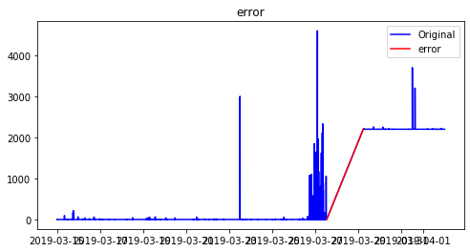

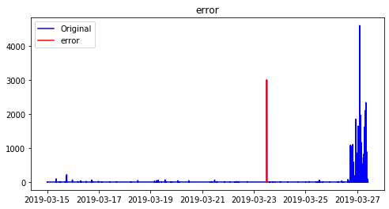

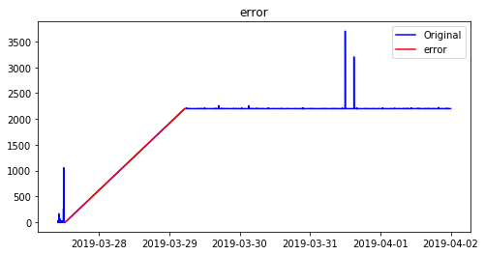

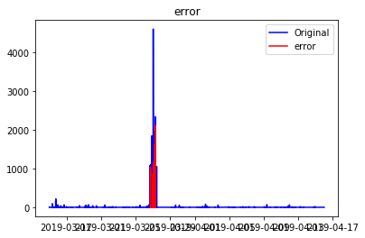

MovingAverage Plot :

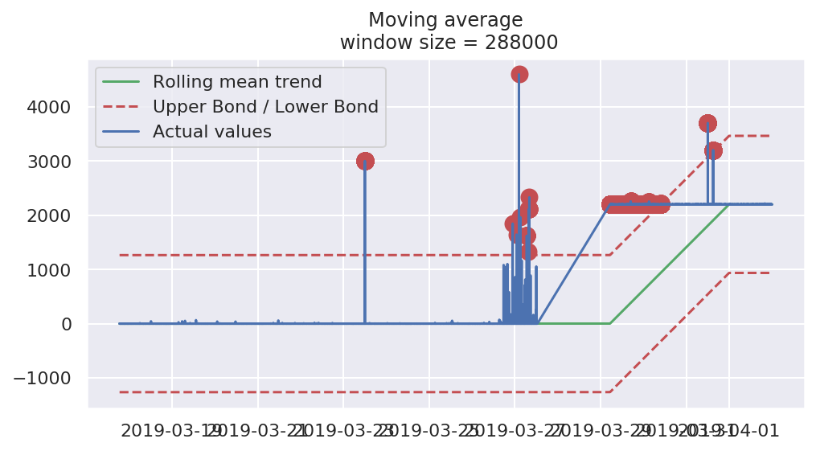
plotMovingAverage(ts, 60*60*80, plot_intervals=True, plot_anomalies=True)#1hour window

plotMovingAverage(ts, 60*80, plot_intervals=True, plot_anomalies=True)#1 min window
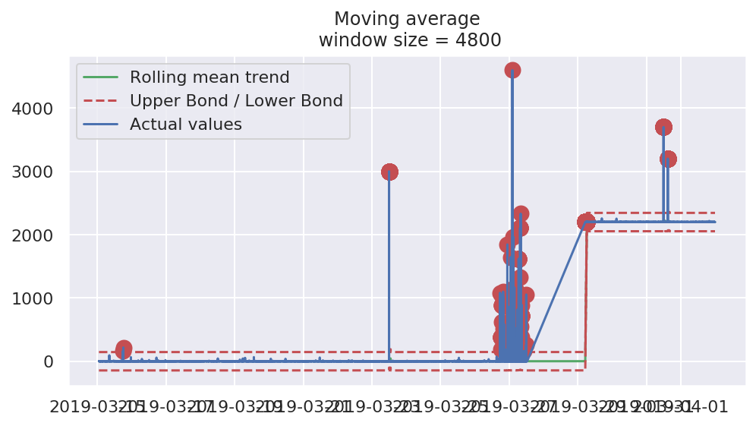

plotMovingAverage(ts, 60*80, scale=26.96, plot_intervals=True, plot_anomalies=True)#with range scaled ~27 times
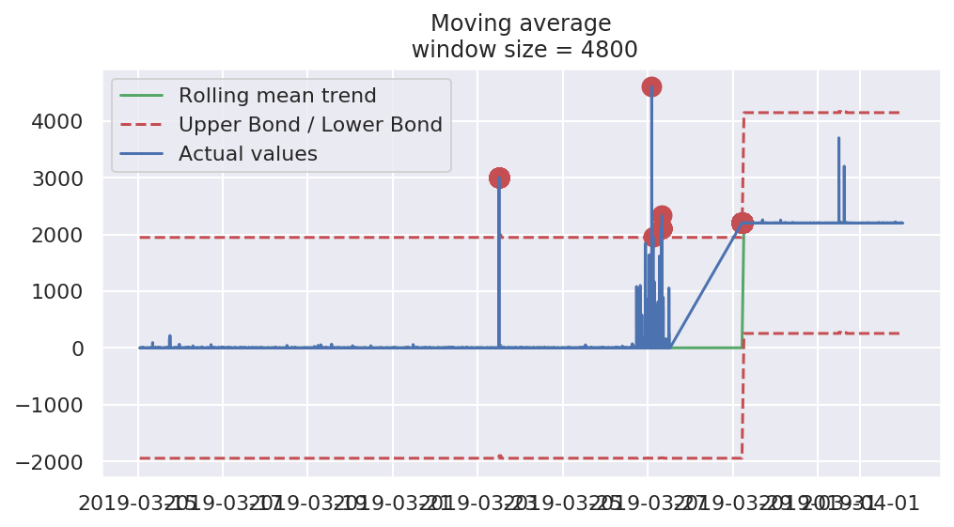

Exponential Smoothing
plotExponentialSmoothing(ts.diskio_serviceTime, [0.05], scale=29.96, plot_intervals=True)
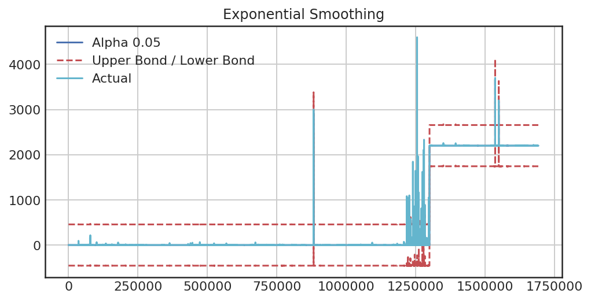

Numenta Input:

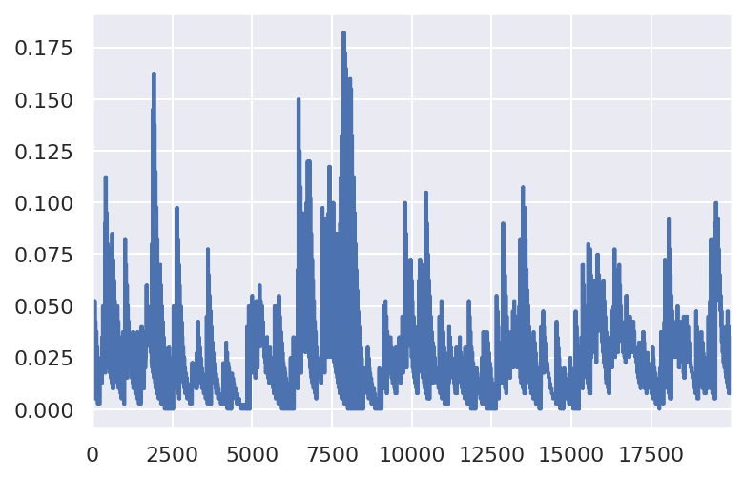

Numenta Output :

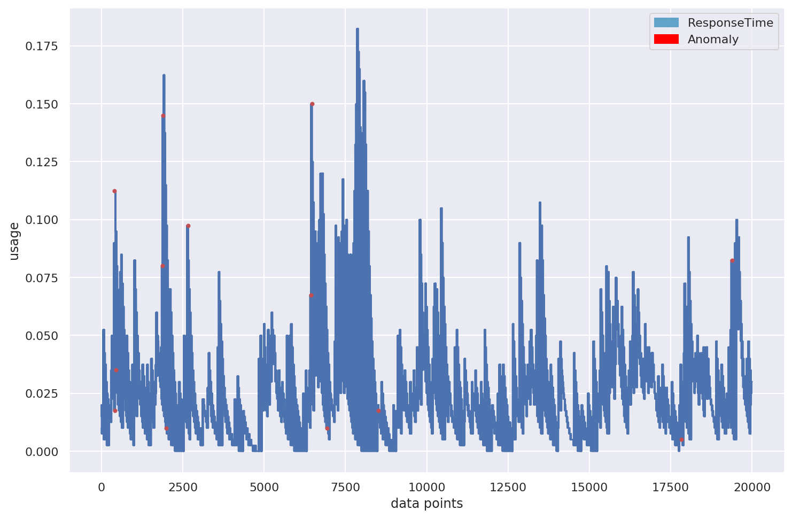

Numenta Input: Change Point Test( 1. train data & 2. test data )

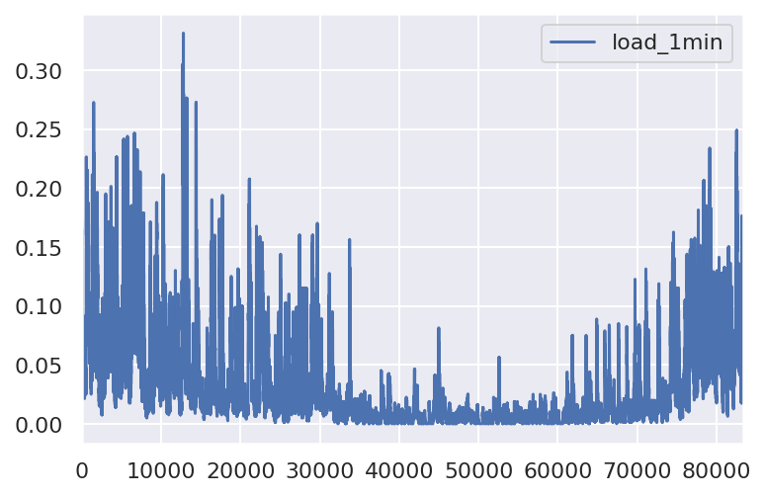

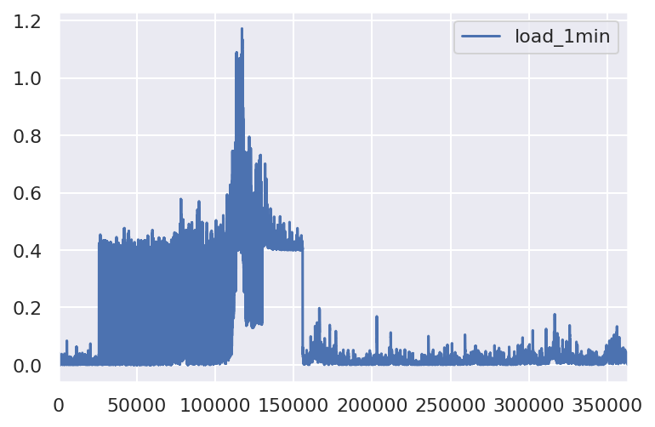

Numenta Output: Change Point Test

